International Conference on Computer Science and Computational Intelligence (ICCSCI 2015)
Weather Forecasting using Deep Learning Techniques
Afan Galih Salman, Bayu Kanigoro, Yaya Heryadi
Computer Science Program, School of Computer Science, Bina Nusantara University, Jakarta, Indonesia
Abstract
Weather forecasting has gained attention many researchers from various research communities due to its effect to the global human life. The emerging deep learning techniques in the last decade coupled with the wide availability of massive weather observation data and the advent of information and computer technology have motivated many researches to explore hidden hierarchical pattern in the large volume of weather dataset for weather forecasting. This study investigates deep learning techniques for weather forecasting. In particular, this study will compare prediction performance of Recurrence Neural Network (RNN), Conditional Restricted Boltzmann Machine (CRBM), and Convolutional Network (CN) models. Those models are tested using weather dataset provided by BMKG (Indonesian Agency for Meteorology, Climatology, and Geophysics) which are collected from a number of weather stations in Aceh area from 1973 to 2009and El-Nino Southern Oscilation (ENSO) data set provided by International Institution such as National Weather Service Center for Environmental Prediction Climate (NOAA).Forecasting accuracy of each model is evaluated using Frobenius norm. The result of this study expected to contribute to weather forecasting for wide application domains including flight navigation to agriculture and tourism.
© 2015 The Authors.Published by Elsevier B.V.
Peer-review under responsibility of organizing committee of the International Conference on Computer Science and Computational Intelligence (ICCSCI 2015).
Keywords:Deep Learning, Recurrent Neural Network, Conditional Restricted Boltzmann Machines, Convolutional Networks, Weather Forecasting.
- Introduction
Weather forecasting has gained attention many researchers from various research communities due to its effect to the global human life. The current wide availability of massive weather observation data and the advent of information and computer technology in the last decade have motivated many researches to explore hidden pattern in the large dataset for weather prediction.
Weather forecasting is an interesting research problem with wide potential applications ranging from flight navigation to agriculture and tourism. The challenges of weather forecasting, among others, are: (i) learning weather representation using a massive volume of weather dataset and (ii) building a robust weather prediction model which exploits hidden structural patterns in the massive volume weather dataset.
In the last decade, many significant efforts in weather forecasting using statistical modeling techniques including machine learning have been reported with successful results [1],[2],[3].
The studies by [4] on deep belief nets (DBNs), [5] on deep networks, [6] on energy-based models have become foundations for the emerging deep learning as deep architecture generative models in the last decade. Deep learning models contain many layers of latent variables and millions of parameters that can be learned efficiently. The word “deep” in deep learning indicates that such neural network (NN) contains more layers than the “shallow” ones as used in typical machine learning models. This multi-layer NN have gained wide research interest after successful implementation of the layer-wise unsupervised pre-training mechanism by [4],[5],[6] that is employed to solve the training difficulties efficiently. The “deep” architecture is very significance in compared with shallow models as NN with deep architecture can provide higher learning ability. Functions that can be compactly represented by a deep architecture might be required to handle an exponential number of computational elements (parameters) to be represented by a deep architecture.
The successful applications of deep learning in various domains, which have been reported by various researchers, have motivated its use in weather representation and modeling. The recent study by [7], for example, proposes to represent weather using hierarchical feature that are learned from a large volume of weather data using deep neural network (DNN).
The objective of our investigations is to explore the potential of deep learning technique for weather forecasting using rich hierarchical weather representations which are learned from massive weather time series data. The models are tested using a large volume of weather data provided by BMKG (Indonesian Agency for Meteorology, Climatology, and Geophysics)which are collected from a number of weather stations in Aceh area from 1973 to 2009and El-Nino Southern Oscilation (ENSO) data set provided by International Institution such as National Weather Service Center for Environmental Prediction Climate (NOAA). In this study, several deep learning models for weather forecasting such as: Conditional Restricted Boltzmann Machine (CRBM) and Convolutional Neural Network (CNN) models will be explored and compared with the prominent time series forecasting models such as: Recurrent NN.
The rest of this paper is organized as follows. Chapter 2 describes related works and chapter 3 explains research methodology.
- Related Works
2.1WeatherForecasting Problem
In the last decade, many significant efforts to solve weather forecasting problem using statistical modeling including machine learning techniques have been reported with successful results. Input data for weather forecasting is high-dimensional weather time series data which are collected from a number of weather stations from various regions. The study by [8] proposes Recurrent NN models to forecast regional annual runoff. The study by Chen and Hwang (2000) proposes a fuzzy time series model for temperature prediction based on the historical data that are represented by linguistic values. The study by [2] has shown that ensemble of artificial neural networks (ANNs) successfully learns weather patterns based on weather parameters including temperature, wind speed and relative humidity. [9]proposes NN for rainfall forecasting using statistical downscaling.[3]proposes a Chaotic Oscillatory-based Neural Network for short term wind forecasting using LIDAR Data. [10]proposes a long term rainfall forecasting model using Integrated ANN and fuzzy logic wavelet model.[11]proposes precipitation index drought forecasting using NN, wavelet NN, and Support Vector Regression.[12]proposes a rainfall forecasting model based on an ensemble of artificial NN.
2.2 Recurrent Neural Network
Recurrent neural network (RNN) is an artificial NN [13]used for time series prediction. Elman networks is a class of RNN consists of one or more hidden layer. The first layer has the weight that is obtained from the input layer every layer will receive weight from the previous layer. This network usually uses the activation function of sigmoid bipolar for the hidden layer and linear function (purelin) for the output layer. Unlike backpropagation, this Elman network has activation function that can be in the form of any function both continue and discontinue. Delay that is happened in the connection between the input layer and the first hidden layer in the previous time (t-1) can be used in the current time (t). The unique of the recurrent neural network is the feedback connection which conveys interference information (noise) at the previous input that will be accommodated to the next input.
Let and be input and output time series respectively; the three connection weight matrices are , , and ; hidden and output unit activation functions are and ; the behaviour of the recurrent network can be described by the pair of non-linear matrix equations:
(3.1)
. (3.2)
Where: represent a state of a dynamical system. is a set of values that summarizes all the information about the past behaviour of the system that is necessary to provide a description of its future behaviour.
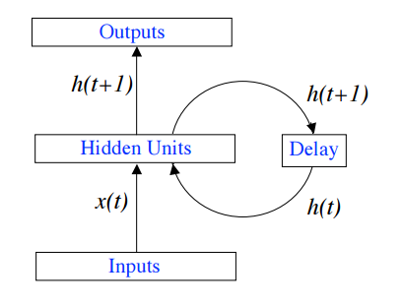
Figure 1.Recurrent Neural Network Model
The RNN parameters are learned using Backpropagation Through Time (BPTT) learning algorithm which is the natural extension of standard back-propagation that performs gradient descent on a complete unfolded RNN (see Figure 2). If a network training sequence starts at time ends at time , the total cost function is simply the sum over time of the standard error function at each time-step:
(3.3)
and the gradient descent weight updates have contributions from each time-step:
(3.4)
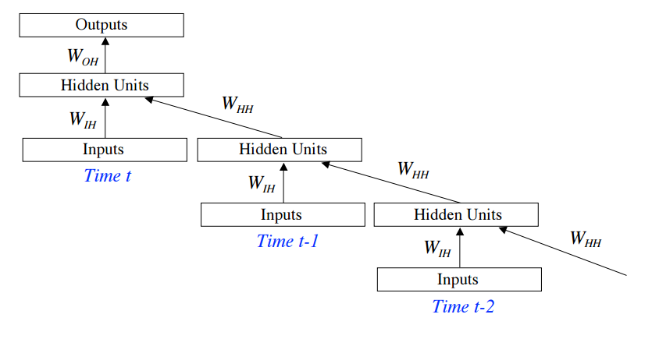
Figure 2.Unfolded Recurrent Neural Network Model
2.3 Conditional Restricted Boltzmann Machines (CRBM)
Conditional Restricted Boltzmann Machines(CRBMs) are deep learning models that have been applied with promising results to solve various problems such as: collaborative filtering, classification, and modelling motion capture data problems [14].
A building block of CRBMs is Restricted Boltzmann Machine (RBMs) which can be defined as an undirected graphical model that defines a probability distribution over a vector of observed (visible) variables v and a vector of latent (hidden) variables h. An RBM defines a joint probability over v and h such that:
(3.5)
Where: is a normalization constant and is an energy function given by:
(3.6)
Where: is a matrix of pairwise weights between elements of and ; and are biases for the visible and hidden variables respectively. In order to obtain , is marginalized from the joint distribution as follows:
(3.7)
Where: is called the free energy and can be computed in time linear proportional to the number of elements in and .
(3.8)
The first practical method for training RBMs was reported by [15]. RBMs is trained using Gradient Descent training algorithm in negative log-likelihood for some set of training vectors . By writing the log-likelihood as:
(3.9)
and differentiating with respect to parameter we get the gradient:
(3.10)
The first term in the above equation known as the positive gradient and corresponds to the expected gradient of the energy, where the expectation is with respect to . The second term in the equation known as a negative gradient.The negative gradient is an expectation over the model distribution and is intractable to compute exactly for all but smallest model. The negative gradient is estimated by drawing samples from the model using MCMC methods.A graphical illustration of an RBM is shown below.
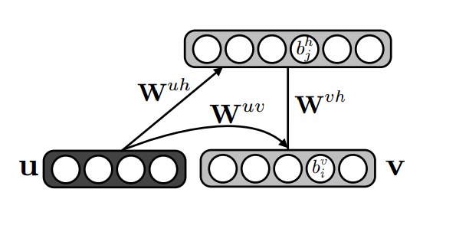
Figure 3.Conditional Restricted Boltzmann Machine Model
A CRBM models the distribution by using an RBM to model and using to determine the RBM’s biases or weights dynamically. The free energy is defined as:
(3.11)
(3.12)
Where:
(3.13)

The CRBM models the following probability distribution:
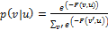 (3.14)
Learning in CRBM models involve doing gradient descent in negative log conditional likelihood as follows.
(3.15)
Once CRBM parameters have been learned, the CRBM can be applied for structured output prediction as reported by [14].
2.4 Convolution Network (CN)
Convolutional network (CN) models [16], [17] as well as neocognitrons[18]known as one of biologically inspired models. CNN models have been successfully applied to many recognition asks including: (i) digit recognition using MNIST dataset [19], (ii) object recognition using NORB dataset [20], and (iii) natural language processing [21].
LeCun et al.in [17] defines CN as a trainable multistage architectures composed of multiple stages whose input and output of each stage are sets of arrays called feature maps. Although a simple CN is composed of one, two or three such 3-layer stages, followed by a classification module, a deep architecture CN may have several stages.In an application of CN using colour images as input, for example, each feature map would be a 2D array containing a colour channel of the input image (for an audio input each feature map would be a 1D array, and for a video or volumetric image, it would be a 3D array). Having been trained using input dataset, each feature map represents a particular feature.
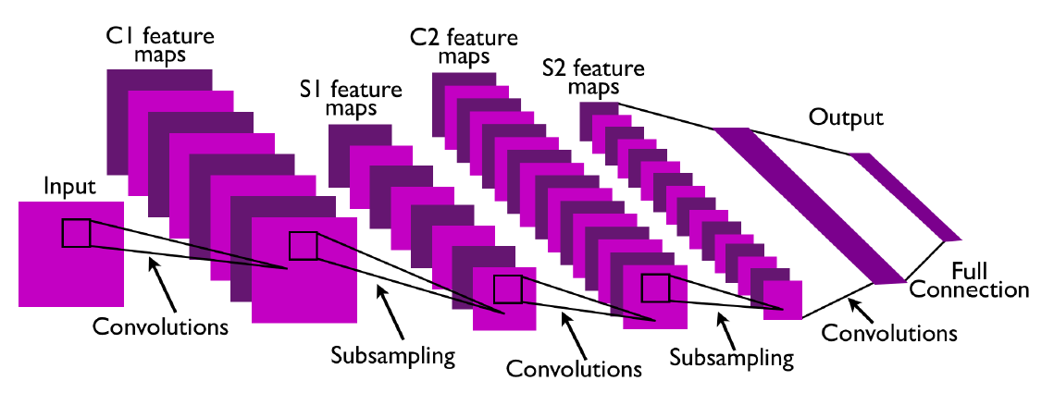
Figure 4. A typical Convolutional Networks Architecture with Two Feature Stages [17]

The common unsupervised training method for CNN to learn the filtercoefficients in the filter bank layers is called Predictive Sparse Decomposition Algorithm [22].
- Research Methodology
  - Preliminary Research
As a preliminary study has been implemented to explore Recurrent NN using heuristically optimization method for rainfall prediction based on weather dataset comprises of ENSO variables[8]. In this preliminary study, the training dataset are divided into two subsets. The first training dataset is divided into: 75% of the total data for training and 25% of the total data for testing. The second training dataset is divided into: 50% of the total data for training and50% of the total data for testing.
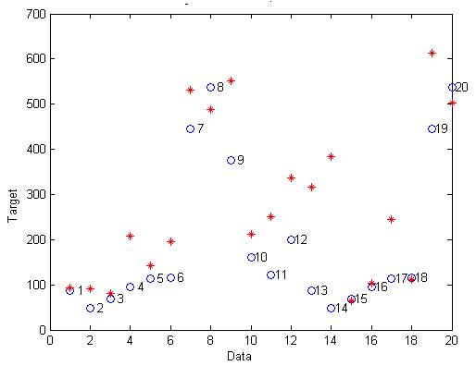 | 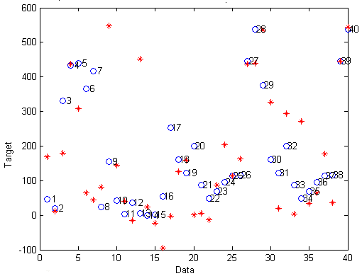
- Result of First Experiment | - Result of Second Experiment

Figure 5: The best prediction value (output o) and the best actual value (target *) of neural network recurrent resilient backpropagationwith the first data group leap 1.

In both experiments, the ENSO variables: wind, SOI,SST and OLR used as independent variables and rainfall as a forecasted variable. Among tested leap 1, 2 and 3, the leap 1 give the best prediction result with resilient backpropagation. The resulted maximum R²value from the first experiment is 84,8% with RMSE value is 125. While, the maximum maximum R²value from the second experiment is 59,9% within the R² with RMSE value is 155,29.
  - Research Frameworks
The framework for this study can be described using the following diagram.

Training Phase
Data Preprocessing
Weather data
RNN
CRBM
CN

Testing Phase
RNN
CRBM
CN
Weather Forecasting
Figure 6. The Research Framework

In this study, the main experiment phases are: training phase of RNN, CRBM, and CN models; and testing each of these models.

  - Dataset
The weather data that in this study comprises of:
- ENSO dataset. ENSO dataset comprises of: Wind, Southern Oscillation Index (SOI), Sea Surface Temperatur (SST) andOutgoing Long Wave Radiation (OLR). The data are provided by International Institution such as National Weather Service Center for Environmental Prediction Climate (NOAA).
- Weather dataset. The weather data set such as Mean Temperature, Max Temperature, Minimum Temperature, Precipitation Temperature, Relative Humidity, Mean Sea Level Pressure, Mean Station Pressure, Visibility , Average Win, Maximum Wind, Wind and Rainfall in Aceh area from 1973 to 2009 provided by BMKG (Indonesian Agency for Meteorology, Climatology, and Geophysics).
Before being used as training dataset, the data are normalized using the following formula. Let and ybe a raw and normalized weather variable.
(3.16)
  - Model Training
Three weather forecasting models will be explored in this study which are namely: (i) Recurrence Neural Network (RNN), (ii) Conditional Restricted Boltzmann Machine (CRBM), and (iii) Convolutional Network (CN). Each of these models will be trained and tested using the predetermined weather dataset.
Parameter learning algorithm for each model, for example: gradient descent for CRBM,is implemented to gaintesting error below the predetermined threshold value.
  - Performance Evaluation
Model performance will be evaluated using k-fold Cross-validation technique which runs as follows. First, the weather dataset will be divided randomly into k folds. Each of k-chuck contains approximately m/k of the total data. Given a set of m training data, a single run of k-fold cross validation proceeds as follows. For i = 1, . . . , k:
- Train the model using all the data that do not belong to fold i.
- Test the model on all the data in fold i.
- Compute which is the number of examples in fold i that were wrongly classified.
- Compute accuracy (in percent) to estimate the classifier error using the following formula:
(3.17)
To obtain accurate estimate to the classifier accuracy, k-fold cross validation is run several times, each with a different random arrangement. Let ,…, be the accuracy estimates obtained in runs. The estimate for the model performance is an error with standard deviation where:
(3.18)
, (3.19)
  - Research Roadmap
Result of Literature review
Experiment result 3
Experiment result 1
Experiment result 2

Literature review
Exploring RNN Model
Exploring RBM Model

Exploring CN Model

Q1
Q2
Q3
Q4
Time
Figure 7. The Research Roadmap
As can be seen in the above figure, this research is planned to be completed in 2 years (4 Quarters).
References
- Chen, S.-M., and J.-R. Hwang. "Temperature prediction using fuzzy time series." Systems, Man, and Cybernetics, Part B: Cybernetics, IEEE Transactions on 30.2 (2000): 263-275.
- Maqsood, I., M. R. Khan, and A. Abraham. "An ensemble of neural networks for weather forecasting." Neural Computing & Applications 13.2 (2004): 112-122.
- Kwong, K. M., Liu, J. N. K., Chan, P. W., and Lee, R. “Using LIDAR Doppler velocity data and chaotic oscillatory-based neural network for the forecast of meso-scale wind field,” In Evolutionary Computation, 2008. CEC 2008.(IEEE World Congress on Computational Intelligence). IEEE Congress on (pp. 2012-2019), 2008.
- Hinton, G., S. Osindero, and Y.-W.Teh. "A fast learning algorithm for deep belief nets." Neural computation 18.7 (2006): 1527-1554.
- Bengio, Y., Lamblin, P., Popovici, D., and Larochelle, H. “Greedy layer-wise training of deep networks.,”Advances in neural information processing systems, vol. 19 (153) 2007.
- Ranzato , M., Y., Boureau, L., Chopra, S., &LeCun, Y. “A unified energy-based framework for unsupervised learning,” In Proc. Conference on AI and Statistics (AI-Stats), vol. 20, 2007.
- Liu, J. N. K., Y. Hu, Y. He, P. W. Chan, and L. Lai. "Deep Neural Network Modeling for Big Data Weather Forecasting." Information Granularity, Big Data, and Computational Intelligence. Springer International Publishing, 2015. pp. 389-408.
- Salman. “Recurrent Neural Network Modelling using Heuristic Optimization for Rainfall Forecasting using ENSO Variables,” InstitutPertanian Bogor, Thesis, 2006.
- Normakristagaluh P., “Artificial Neural Network for Rainfall Forecasting in Statistical Downscaling,” InstitutPertanian Bogor, Thesis, 2004.
- Afshin. “Long Term Rainfall Forecasting by Integrated Artificial ,Neural Network-Fuzzy Logic-Wavelet Model in Karoon Basin,” Scientific Research and Essay vol 6(6),pp.1200-1208; 2011.
- Belayneh, A. “Standard Precipitation Index Drought Forecasting Using Neural Networks,Wavelet Neural Networks, and Support Vector Regression,”Hindawi Publishing Corporation Applied Computational Intelligence and Soft Computing Volume, Article ID 794061, 13 pages doi:10.1155/2012/794061; 2012.
- Gong, Z. “An Ensemble of Artificial Neural Network in Rainfall Forecasting,” ICTer, 2012
- Rumelhart, D., G. Hinton, and R. Williams. “Learning internal representations by error propagation,” In Parallel Dist. Proc., pp. 318-362. MIT Press, 1986.
- Mnih, V., H. Larochelle, and G. Hinton. “Conditional restricted Boltzmann machines for structured output prediction,” In UAI 27, 2011.
- Hinton, G. E., and R. R. Salakhutdinov. "Reducing the dimensionality of data with neural networks." Science vol. 313.5786, pp. 504-507, 2006.
- LeCun, Y., and Y.Bengio. "Convolutional networks for images, speech, and time series." The handbook of brain theory and neural networks 3361: 310, 1995.
- LeCun, Y., Bottou, L., Bengio, Y., and Haffner, P. “Gradient-based learning applied to document recognition,” Proceedings of the IEEE, 86(11), pp. 2278-2324, 1998.
- Fukushima, K. "Neocognitron: A hierarchical neural network capable of visual pattern recognition." Neural networks 1.2 pp. 119-130, 1988.
- Simard, P. Y., D. Steinkraus, and J. C. Platt. "Best practices for convolutional neural networks applied to visual document analysis." 2013 12th International Conference on Document Analysis and Recognition. Vol. 2. IEEE Computer Society, 2003.
- LeCun, Y., F.J. Huang, and L.Bottou. "Learning methods for generic object recognition with invariance to pose and lighting." Computer Vision and Pattern Recognition, 2004. CVPR 2004. Proceedings of the 2004 IEEE Computer Society Conference on. Vol. 2. IEEE, 2004.
- Collobert, R., and J. Weston. "A unified architecture for natural language processing: Deep neural networks with multitask learning." Proceedings of the 25th international conference on Machine learning. ACM, 2008.
- Kavukcuoglu, K., M. Ranzato, and Y. LeCun, “Fast inference in sparsecoding algorithms with applications to object recognition,” Tech. Rep.,2008, tech Report CBLL-TR-2008-12-01.

* Corresponding author. Tel.: +0-000-000-0000; fax: +0-000-000-0000. E-mail address:author@institute.xxx

